WIRESHARK FOR THREAT HUNTING

Network Traffic Analysis & Detection
In-Depth Practical Task | September 3–7, 2026
Prepared by: Chetna Solanki

1. Overview
As part of my cybersecurity threat-hunting practical, I used Wireshark to capture and analyze network traffic in a controlled VMware lab environment.
The main objective was to establish a normal traffic baseline and investigate simulated suspicious patterns in ARP and DNS traffic.

2. Objectives
- Establish a baseline of normal network traffic.
- Analyze ARP and DNS communication.
- Investigate abnormal ARP behavior.
- Perform a controlled ARP spoofing simulation.
- Analyze repeated DNS query patterns.
- Use Wireshark filters for focused investigation.
- Document findings from a threat-hunting perspective.

3. Lab Environment
Component | Configuration
Security VM | Kali Linux
Kali IP | 192.168.95.128
Kali Interface | eth0
Target VM | Ubuntu
Ubuntu IP | 192.168.95.129
Ubuntu Interface | ens33
Gateway | 192.168.95.2
Tool | Wireshark
Platform | VMware
All practical activities were performed within a controlled lab environment.

4. Day 1 – Baseline Traffic Analysis
The first phase focused on capturing normal network traffic using Wireshark.
Wireshark was configured on the Kali Linux eth0 interface. Normal network activity was captured before performing any simulated suspicious activity.

ARP Analysis
The following Wireshark display filter was used:
arp
Normal ARP requests and replies were observed between systems in the lab.
Establishing this baseline was important because understanding normal ARP behavior helps identify unusual ARP activity during later investigation.
Figure 1: Normal ARP Traffic
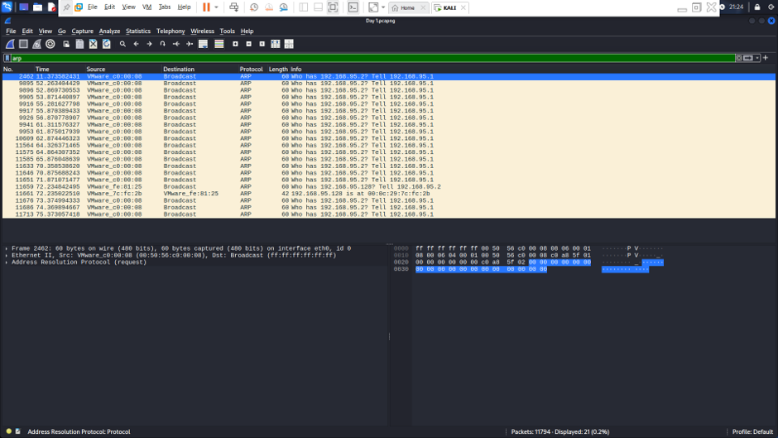

DNS Analysis
The following Wireshark display filter was used:
dns
Normal DNS queries and responses were observed from the lab systems.
The DNS traffic provided a baseline for comparing later simulated DNS activity.
Figure 2: Normal DNS Traffic
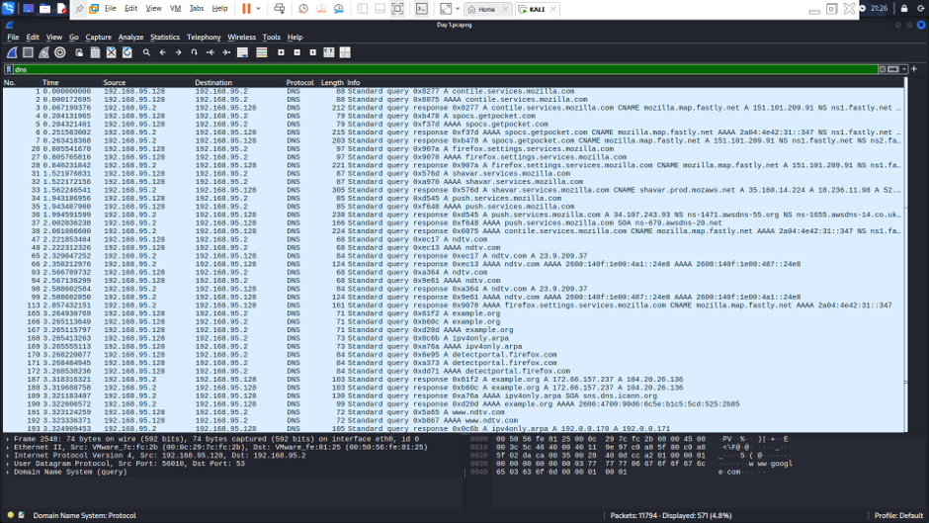

5. Day 2 – Suspicious Traffic Investigation
The second phase focused on controlled simulations of suspicious-looking network behavior.
Two activities were performed:
- Controlled ARP spoofing simulation
- Benign repeated DNS query simulation

5.1 Controlled ARP Spoofing Simulation
ARP spoofing is a technique in which forged ARP messages can cause incorrect IP-to-MAC address associations.
For this practical, the activity was performed only inside the controlled VMware lab environment.
The following commands were used:
sudo arpspoof -i eth0 -t 192.168.95.129 192.168.95.2
sudo arpspoof -i eth0 -t 192.168.95.2 192.168.95.129
Wireshark was monitored using:
arp

Observations
The capture showed repeated ARP replies and unusual IP-to-MAC association activity compared with the normal baseline.
This demonstrated how repeated or unexpected ARP replies can become an indicator for further investigation.
Figure 3: Controlled ARP Spoofing Activity
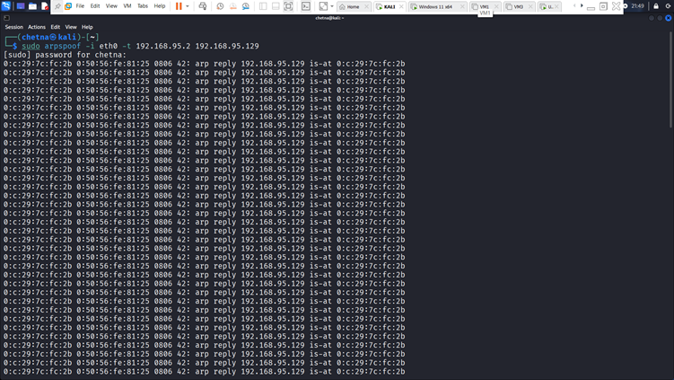

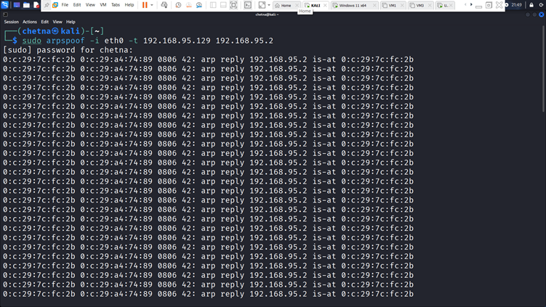
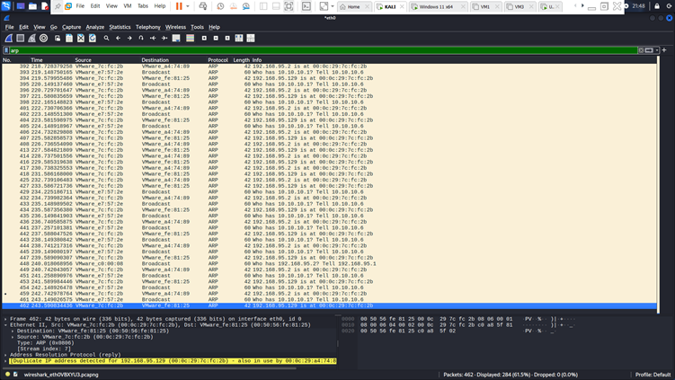

5.2 DNS Threat-Hunting Simulation
A benign DNS simulation was performed using the reserved example.com domain.
The following command was executed:
for i in {1..20}; do dig "x$i-test.example.com"; done
This generated multiple DNS requests such as:
x1-test.example.com,x2-test.example.com,x3-test.example.com
Wireshark was then used with:
dns

Observations
The traffic showed repeated DNS requests with changing subdomains.
This helped demonstrate how unusual DNS query patterns can be identified during network threat hunting.
Figure 4: Simulated DNS Activity
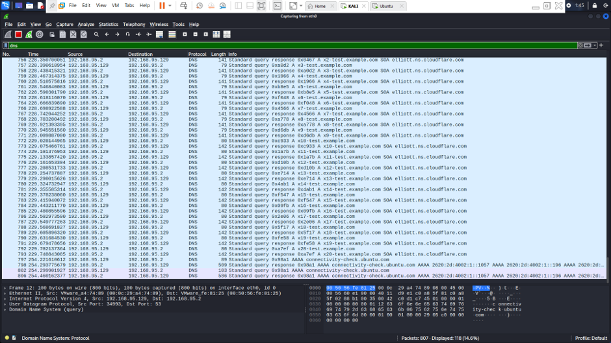

6. Day 3 – Wireshark Filters & Detection
The final phase focused on using Wireshark display filters to investigate network traffic more efficiently.

Filters Used
ARP
arp
Used to analyze ARP requests and replies.
DNS
dns
Used to analyze DNS queries and responses.
TCP
tcp
Used to analyze TCP communication.
UDP
udp
Used to analyze UDP communication.
ICMP
icmp
Used to analyze ICMP traffic such as network connectivity and diagnostic communication.
Specific Host
ip.addr == 192.168.95.129
Used to focus the investigation on traffic involving the Ubuntu VM.

Additional Traffic Analysis Screenshots

Figure 5: TCP Traffic Analysis
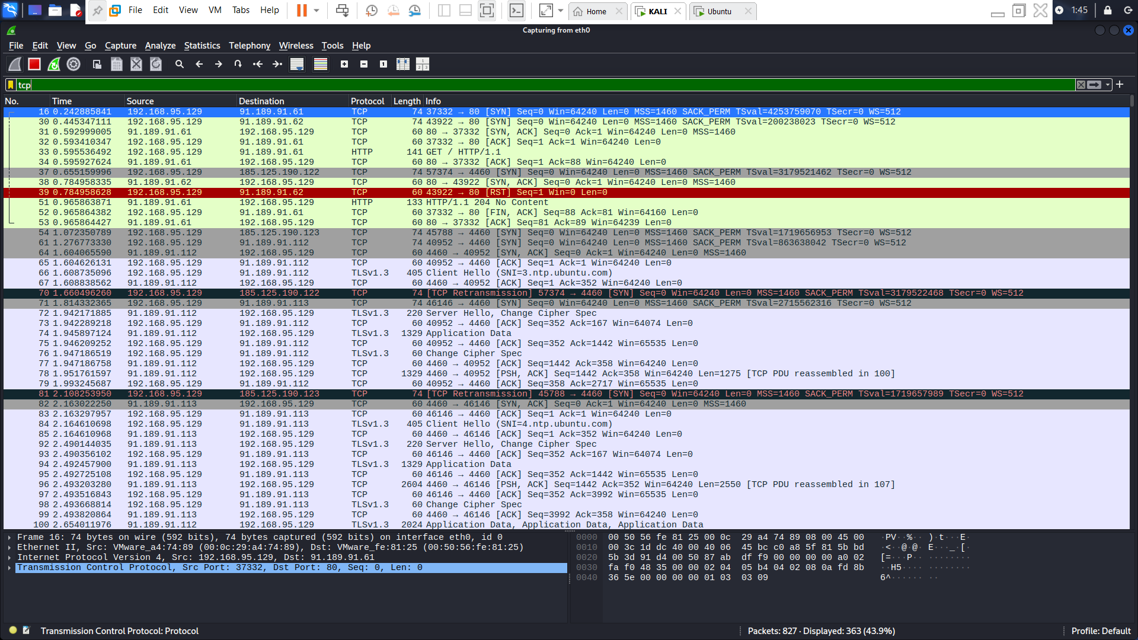
The TCP capture demonstrates packet-level visibility into TCP-based network communication.
Figure 6: ICMP Traffic Analysi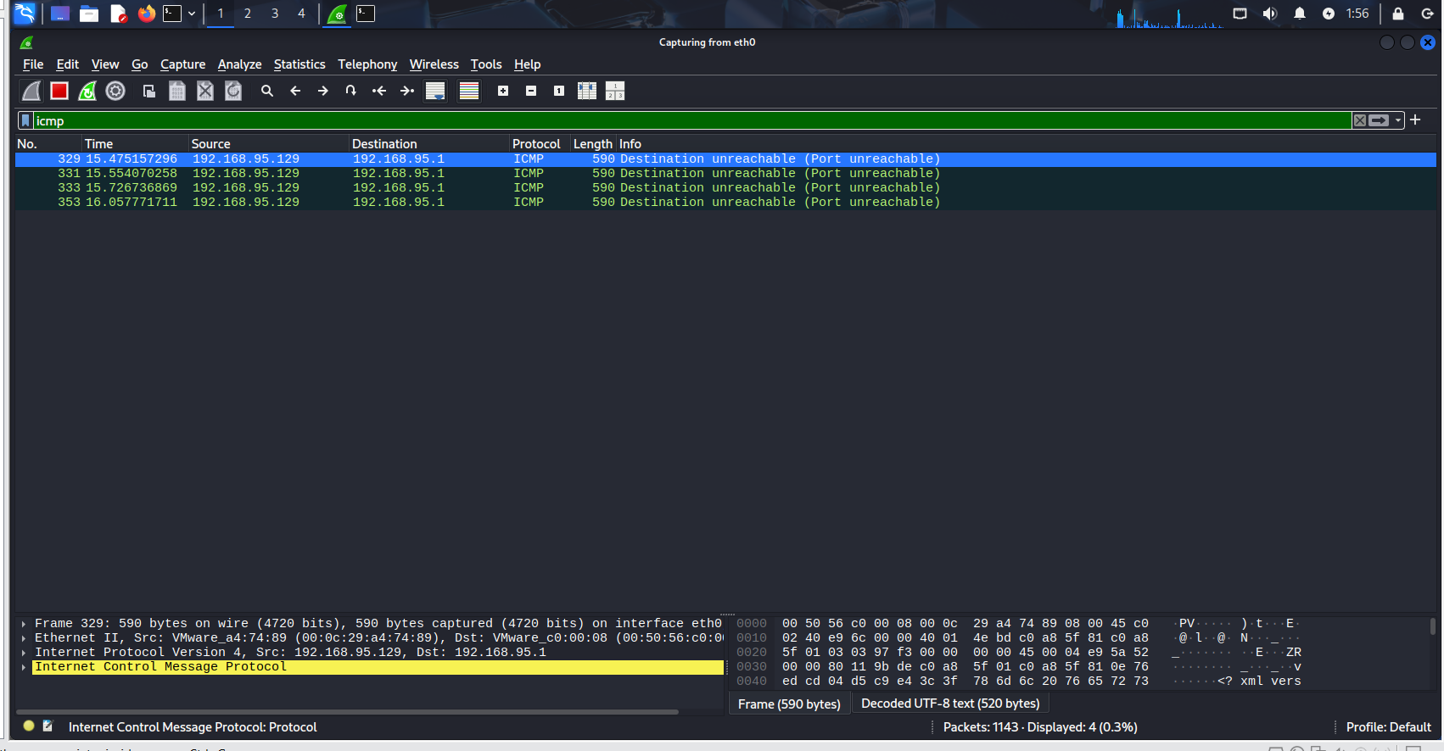
The ICMP capture demonstrates how Wireshark can be used to observe network diagnostic and connectivity traffic.
Figure 7: HTTP Traffic Analysis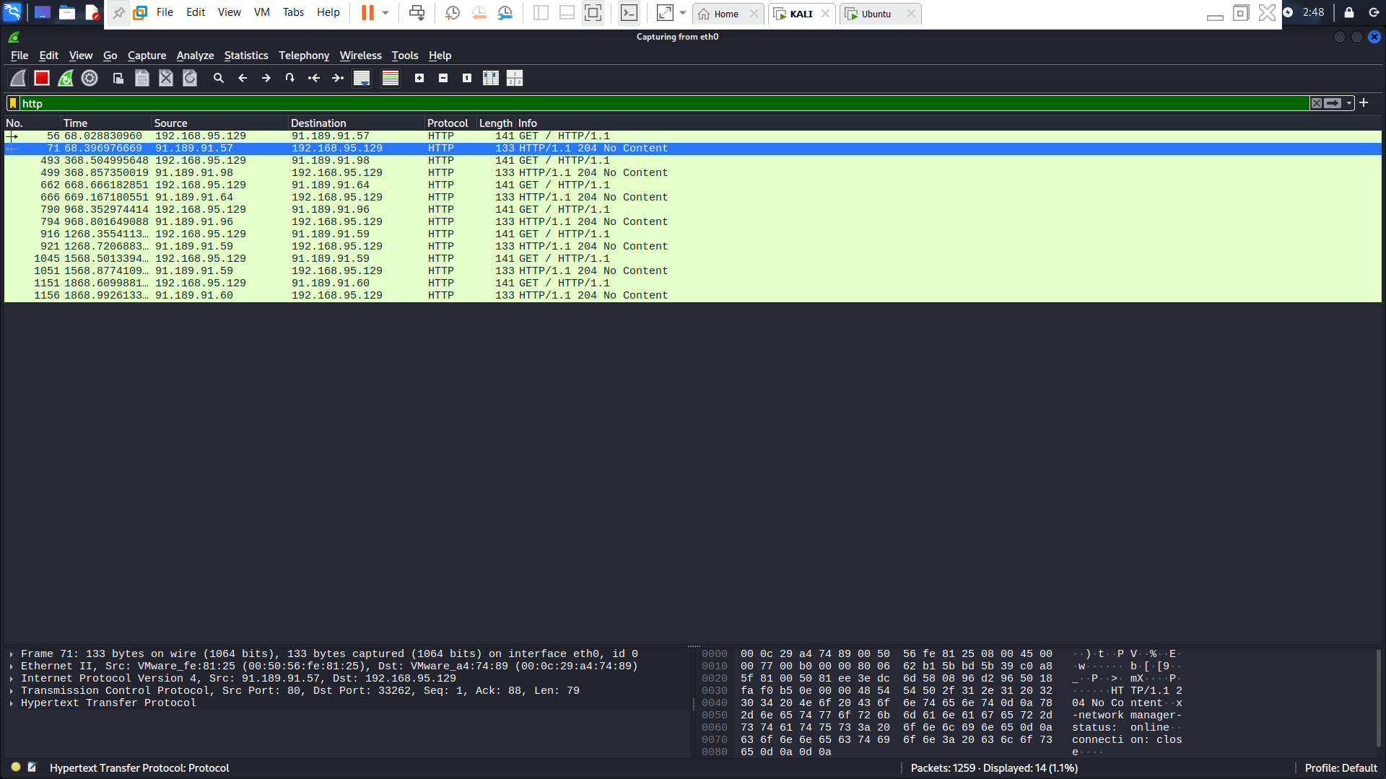
The HTTP capture demonstrates how application-layer web traffic can be examined at packet Level.

7. Key Findings
The practical demonstrated that:
- Establishing a traffic baseline helps identify anomalies.
- Repeated or unexpected ARP replies can indicate possible ARP spoofing.
- Repeated and changing DNS queries can be useful indicators for further investigation.
- Wireshark display filters make packet analysis faster and more focused.
- Host-based filtering helps analysts investigate traffic related to a specific system.
- Packet-level observations should be correlated with other security data before confirming malicious activity.

8. Threat-Hunting Workflow
The practical followed a simple threat-hunting workflow:
Baseline → Monitor → Identify Anomaly → Investigate → Correlate → Document
This approach helps security analysts distinguish normal network behavior from activity that requires further investigation.

9. Practical Outcome
This exercise provided hands-on experience with:
- Network packet capture
- ARP traffic analysis
- DNS traffic analysis
- ARP spoofing detection concepts
- Suspicious DNS pattern investigation
- TCP traffic analysis
- ICMP traffic analysis
- HTTP traffic analysis
- Wireshark display filters
- Basic network threat-hunting methodology

10. Conclusion
Wireshark provides valuable packet-level visibility for network threat hunting and security investigation.
During this three-day practical, I established a normal network baseline, analyzed ARP and DNS traffic, performed a controlled ARP spoofing simulation, and investigated a benign repeated-DNS-query pattern.
The practical strengthened my hands-on understanding of network traffic analysis, anomaly detection, packet investigation, and Wireshark-based threat hunting in a controlled cybersecurity lab environment.

